Case 1-Asia-Japan-Honshu-Mt Hiei-Tools-vesicular andesite-10 kya

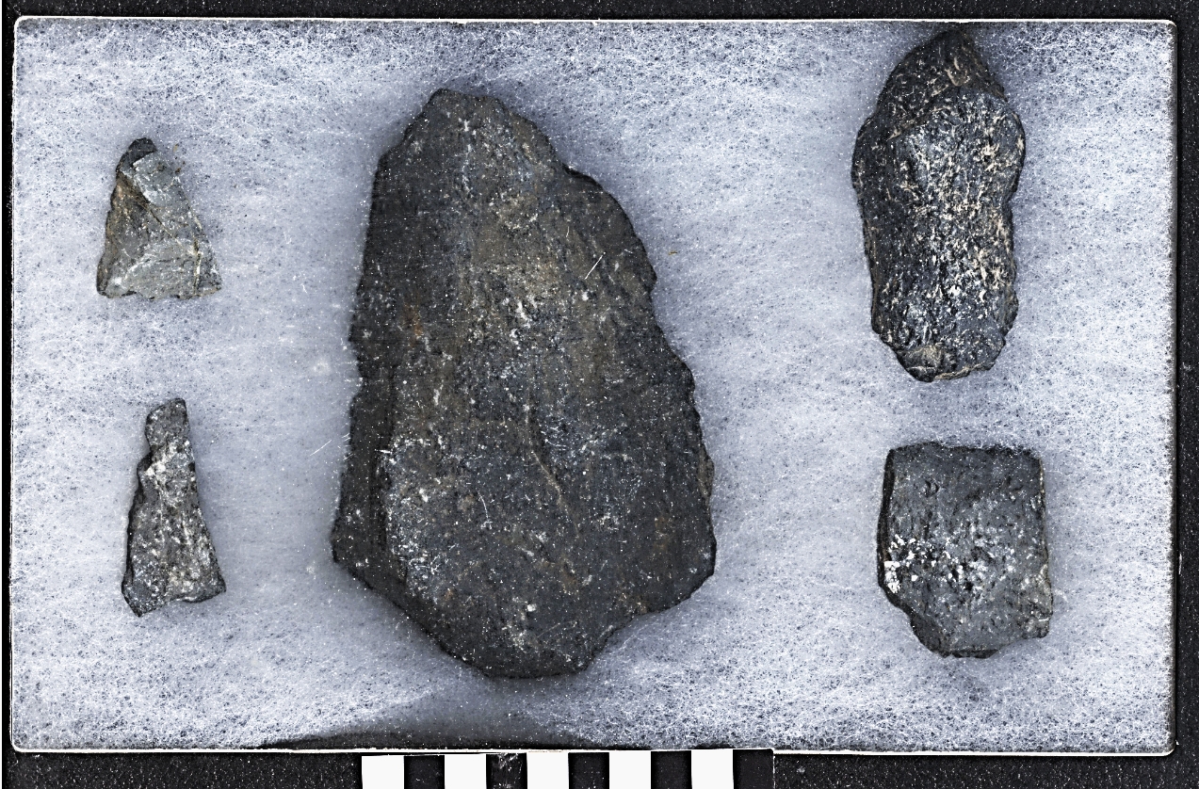

Paleolithic tools from the Mt. Hiei area, Kyoto, Japan. Left to right: 2 projectile points, hand-axe chopper (center), hafted (?) chopper (top), scraper.

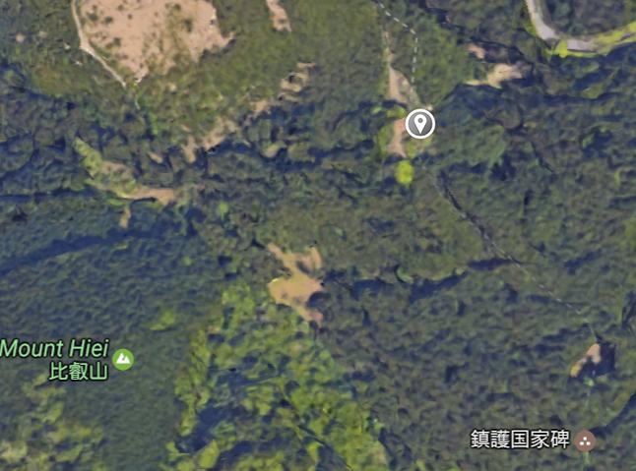 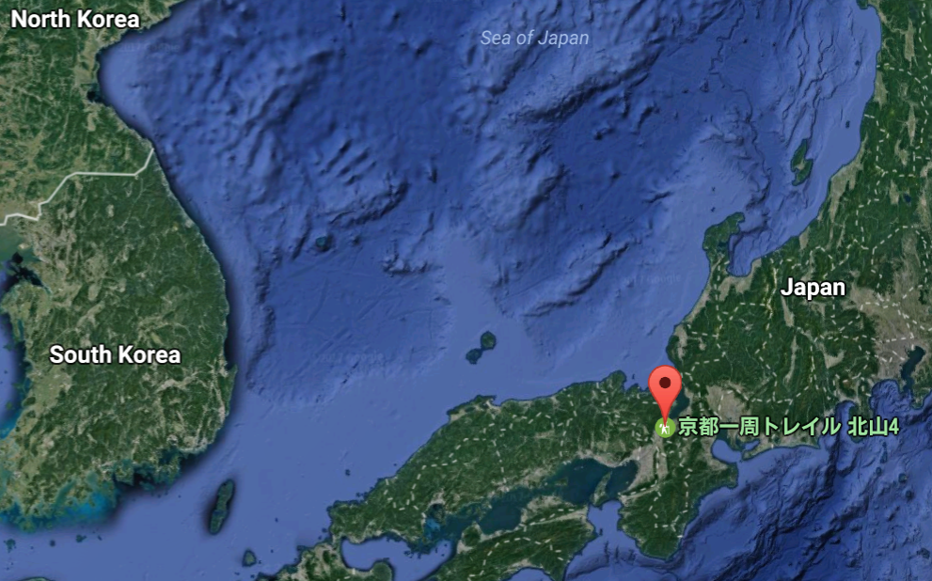

Location of find on Mt. Hiei, 35.0693644,135.8316947.

These Lower Paleolithic tools were found eroding out of a bank on Mt Hiei. They are technologically more “archaic” in their workmanship than Early Upper Paleolithic (EUP) tools. When the EUP suddenly erupted in different regions of Japan ca 38,000 BP more than 500 recorded EUP sites across the archipelago signaled the arrival of H. sapiens *sapiens*. A distinctive aspect of EUP lithic procurement that is NOT represented in the present lithic tools is the strategic use of high-quality lithic raw materials. The present raw material used for these Lower Paleolithic tools can be characterized as “siliceous shale” or “hard” shale, certainly not a high-quality lithic raw material. EUP is defined primarily before the Aira-Tn (AT) tephra fall at 30,000 cal BP and sites in some areas are buried in well-stratified, thick eolian deposits containing key tephras useful in stratigraphic correlation and dating. These tools were leached out of the soil and appear to have been isolated from any organized use of occupation spaces, suggesting that they represent a solitary hunting site. Thus, the question remains, did *Homo sapiens sapiens* produce these tools or was it *Homo erectus*? The chopper resembles the Clactonian technology in England that was the product of either *Homo heidelburgensis* or *Homo erectus* dating to the Lower Paleolithic. If this estimate is correct, then we have unique tools from Mount Hiei to document the period before the arrival of *Homo sapiens sapiens* ca 38,000 BP.

The Currently, as many as 500 EUP sites are recorded across the Japanese Archipelago. Skeletal remains of a Homo sapiens individual is known from a site in Okinawa Island in southwestern Japan from ca. 36,000 cal BP. Although human remains are absent from the EUP sites on the main islands of Japan, these sites are associated with standardized lithic tools, evidence of organized use of occupation spaces, long-distance transport, strategic use of high quality lithic raw materials, and other evidence that is usually regarded as indicative of modern behaviors associated with H. sapiens. In some areas, these sites are buried in well-stratified, thick eolian deposits containing key tephras that are useful for stratigraphic correlation and dating, the available results of which indicate that the EUP of Japan appeared after ca. 38,000 cal BP. are very rare or absent, despite exceptionally intensive field excavations in Japan. This suggests that the

Suzuki, C., ed. 1980. Teradani Iseki [Teradani site]. Kyoto, Japan: Heian Museum of Ancient History. (In Japanese.)